1. We run Cucumber Feature file with Junit Test Runner @RunWith.
2. You can run Cucumber Feature file with TestNG Test Runner or Plain Java.
3. People prefer Junit Test Runner.
4. Let’s run with TestNG Test Runner.
5. 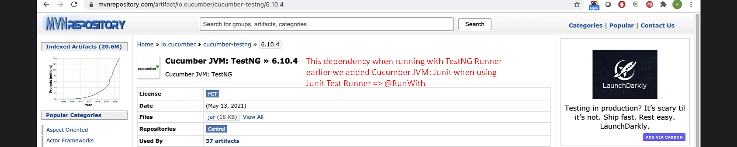
6. A picture containing graphical user interface

   Description automatically generated
7. 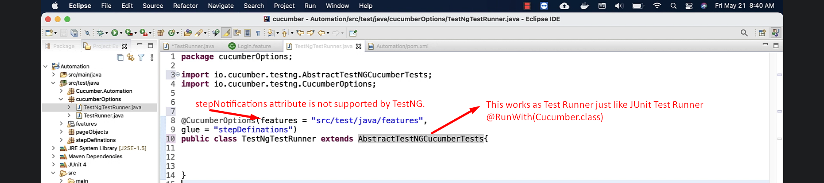
8. Graphical user interface, text, application, email

   Description automatically generated
9. 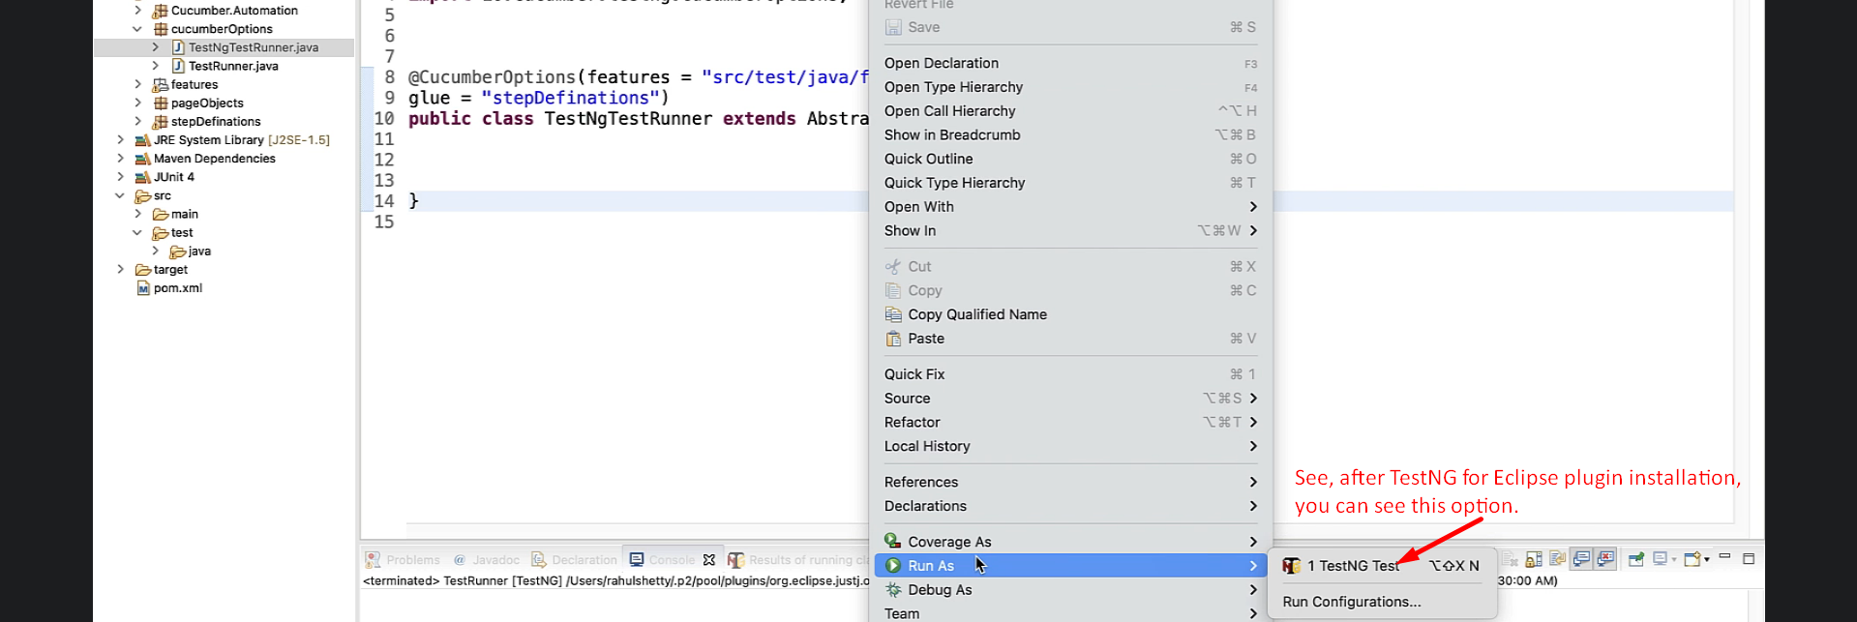
10. Graphical user interface, application

    Description automatically generated
11. 